Great Dunham Gazette
9th September 2022 Issue 1
Mrs Sharon Nour – Headteacher T: 01328 701357 E: office@grd.unity-ed.uk

Welcome
Welcome to our three new reception children Cherry, Thomas and Ralphie who have all settled in really well and had a great first week.
Thank you to FoDS for all your hard work over the summer.
Celebrating
Success
Above and Beyond
Daniel – a conscientious, positive attitude towards his learning and starting year 6 with a smile.
Oliver – for having a positive attitude towards his learning.

Hickling Class – For settling back into school so well.

Head Teachers Award was presented to
Daniel Smith
For a fantastic attitude to learning
Dates for the Dairy
12th September – Inspire Sport starts today
14th September Roald Dahl Day

I am sure you are all aware by now of the sad announcement of the death of Her Majesty, Queen Elizabeth II. As a community, our thoughts and prayers are with her family at this difficult time.
We would like to remind you that we will remain open and throughout the period of public mourning, the day of the Queen’s funeral will be a public holiday and therefore schools will be closed on that day, once we know more we will write to you again.
We also wanted to share that we will talk with the children next week about the death of her Majesty, addressing the news, answering any questions children may have and providing support.
As we all come to terms with what happened, we know that some children will be affected by this in particular. We will keep the school routine as normal as possible today as well as allowing the children opportunities to talk to if they want to.
If you need any further advice on how to support your child, you may wish to access one of the bereavement charities such as Winston's Wish - giving hope to grieving children (winstonswish.org), Child Bereavement UK or Nelson's Journey | Child Bereavement Help for Norfolk | (nelsonsjourney.org.uk). If your child needs extra support, please let us know.
Chris Snudden, Director of Learning and Inclusion Children's Services
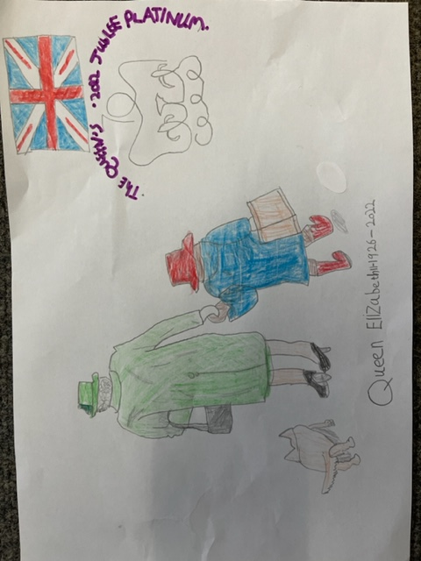
Drawing by Oliver Thurston

FoDS News
Welcome back, we hope you had a wonderful summer, I thought it went extremely quick! I’m still hoping for a few more hot sunny days.
Over the holiday a few Fods members started work on the quiet garden, it’s been a very slow process as we just don’t have the help we desperately need.
We still need help fitting 22m of picket fence, painting it all, levelling the hard-core base, wheelbarrow 4 tonne of sand and then laying the AstroTurf, and with just a few of us is proving to be extremely difficult, if you have skills in any of the work still to be done please get in touch so we can finish the garden for the children.
The front of the school has also had a makeover, which has had a huge amount of praise, please could we kindly ask that you don’t allow your children to walk on the stones on the flower bed, as we don’t want them causing a trip hazard if they end up on the pathway. Thank-you
In other news, we have lots of exciting things planned from now till Christmas
So pop some dates in your diary:
FoDS meeting - Friday 23rd September 2pm @ Church
Macmillan Cuppa & chat - Friday 30th Sept 9.30 - 10.30am
Monster mash disco bash - Thursday 20th October 4-5pm & 5.15-6.15pm
Quiz & Chips family fun evening - Friday 11th November 7 - 9pm
Christmas Fair - date tbc
Don’t forget we have a Facebook group set up for all your Great Dunham School news, events, updates, plus much more, find the page on Facebook Friends of Great Dunham School
It’s for all parents and carers not just Fods members so please join. The school has its own Twitter page @ Great Dunham Primary
We would like to wish you all a wonderful weekend
Lorraine & all at Fods

